AWS TECHNICAL ESSENTIALS PART 1
AWS BASIC
Data center – a server
Availability zone/az - a cluster of 2 or more data centers
Region – a cluster of availability zones
Edge location – a "middle men" between the region and the user. it’s a location where you can small amount of data you need to have ready for the user at all time(popular data/mostly used)
API – the way to interact with aws. Every interaction with AWS is an API call.

Ways to interact with AWS
1.AWS management console – the most basic way, interacting through the main page in aws
2. CLI – a script you can schedule to do as you want, it’s a simple way to automate the process of pulling up basic day to day resources and mundane tasks that need to be done.
SDK - SDK allows you to write code in one of the supported languages and interact with AWS through code. It lets you simply write your action into AWS.

USERS
MFA – an authenticator app which gives a one time code that is used to log into the AWS account, it is combined with the password and email address of the user while logging in to help make the account more secure and harder for unwanted personal to get into
Root user – the main user of the account ,has access to every part of the account and is able to do as he pleases.

Instance type

Instance Families
General Purpose — balanced CPU/memory/network
- t series (t3, t4g) — burstable, cheapest, great for small apps/dev environments
- m series (m6i, m7g) — steady workloads, most common for production
Compute Optimized — high CPU relative to memory
- c series (c6i, c7g) — batch processing, gaming servers, high-traffic web servers
Memory Optimized — high RAM relative to CPU
- r series (r6i, r7g) — databases, caching (Redis), big data
- x series (x2idn) — extreme memory, SAP HANA, in-memory DBs
- u series — ultra-high memory (TBs of RAM)

Storage Optimized — high local disk I/O
- i series (i4i) — NoSQL databases, data warehousing
- d series — dense HDD storage, Hadoop
- h series — high disk throughput
Accelerated Computing — GPUs / special hardware
- p series (p4, p5) — ML training, HPC
- g series (g5) — ML inference, video rendering, gaming
- inf series (inf2) — AWS Inferentia chip, optimized for ML inference
- trn series — AWS Trainium chip, ML training
HPC (High Performance Computing)
- hpc series — tightly coupled HPC workloads, high-speed networking

How to read an instance name
Take m6i.2xlarge as an example:
- m → family (General Purpose)
- 6 → generation (newer = better price/performance)
- i → processor modifier (Intel; a = AMD, g = Graviton/ARM)

- 2xlarge → size
Sizes
The bigger the size the more CPU,RAM,NETWORK BANDWIDTH AND EBS you have the ability to use

How to know which size you need
Symptom | What to scale
High CPU usage | Bigger size or compute-optimized (c family)
High RAM usage / swapping | Bigger size or memory-optimized (r family)
Slow network | Bigger size
Slow disk I/O | Bigger size or storage-optimized (i family)
Tip: its better to start small then scale up if needed

EC2 instance lifecycle
An EC2 instance transitions between different states from the moment you create it until its termination.
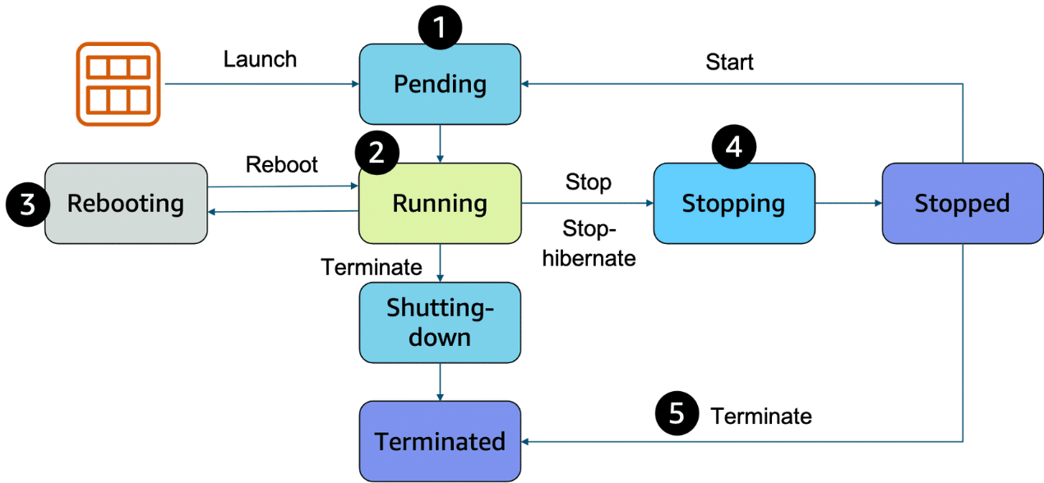
1.Pending – the setup for the EC2 your not billed yet.
2. running – its ready to be used and is billing you, you can stop, reboot and shut it down now.
3. reboot – its like rebooting a computer, it saves all the data stored before and keeps the same public or private IP and host computer
4. stop – its like closing down your laptop, it is possible it will be placed in a new physical server. It saves its IP address and last data stored on it BUT RAM is wiped it will need a full OS boot next time it is started.
5. stop hibernate – the difference is that its ready to open and resume without needing a full OS boot, RAM is stored in the EBS and restored from there

When to use which
- Stop → most common, fine for servers/apps that boot fast and don't need state preserved
- Hibernate → useful when you have a long-running process or heavy in-memory state you want to resume quickly (e.g., a dev environment with many things open, or a long computation paused mid-way)
6. terminated – you cannot use the machine anymore you will lose its IP, it will not bill you and all information on it is erased.
Containers
Virtual machines/VM – a computer running in a data center your connected to, like a EC2. they have a kernel and an OS system
Kernel – the base of an OS system and is installed on the VM, is NOT installed in a container.
Containers – a container is a way to package an application with everything it needs to run, it contains a mini runtime environment with its code, tools, images and more, it connects to the hosts computer and runs using Linux. If your computer doesn’t have Linux(windows, mac) you use a tool (usually docker) to run a Linux VM to use as the kernel. It does NOT include a kernel and riles on the host to have one or a tool to install it.

Simple analogy
Think of an apartment building:
- Kernel = the building's infrastructure (electricity, plumbing, elevators)
- Docker = the building manager (assigns apartments, sets rules)
- Container = a tenant (lives independently, but shares the building's infrastructure)
The manager doesn't become the electricity — he just manages who uses it and how much.
ECS – a tool made for AWS to run containers on EC2, it is only on AWS and is simpler then EKS, it is also able to run on Linux and windows AMI. In ECS a container is called a task.
EKS – the industry standard for running containers, it is an open source platform that is more popular and more complex and expansive then ECS. Containers running on it are called pods.
ECR – a place to store container images, EKS & ECSA both can pull from it.
AWS FARGATE – fargate manages the EC2 scale and instances that way you can focus on the containers and uses of ESC & EKS.
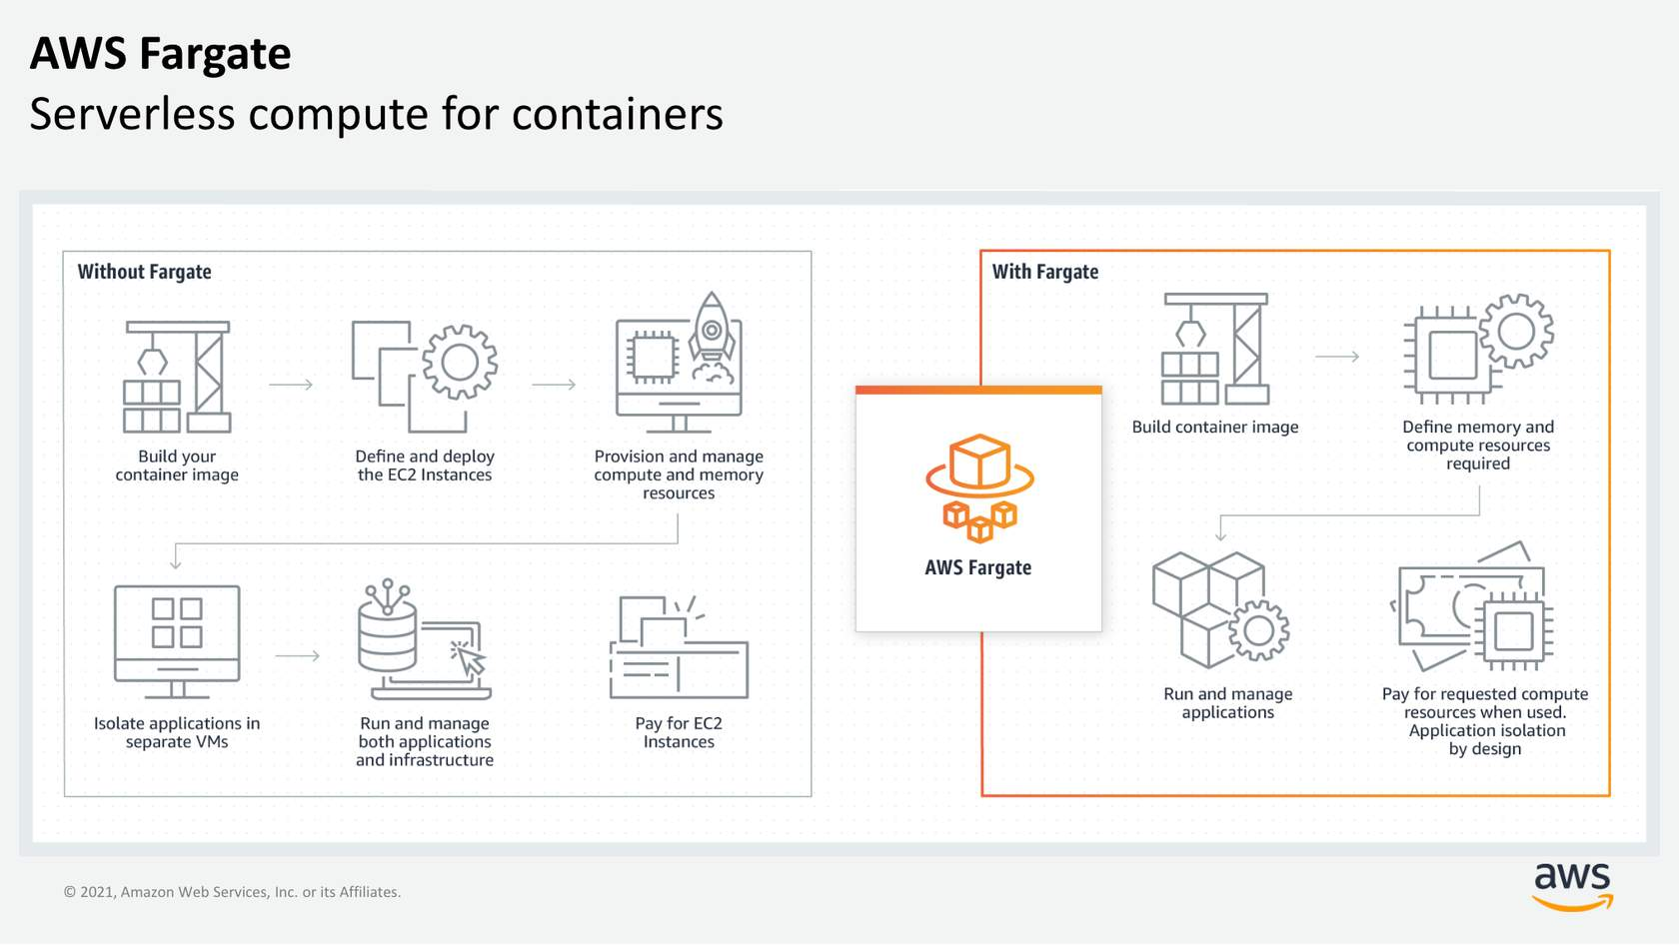
LAMBDA – a lambda is a function to which you can create triggers that will make sure that LAMBDA only starts to work when they are activated(like an if statement in coding) you only get billed for when its used.
NETWORKING
IPv4 notation – a decimal number built out of a 32 bit binary format IP address 4 different binary numbers each one made of 8 1&0
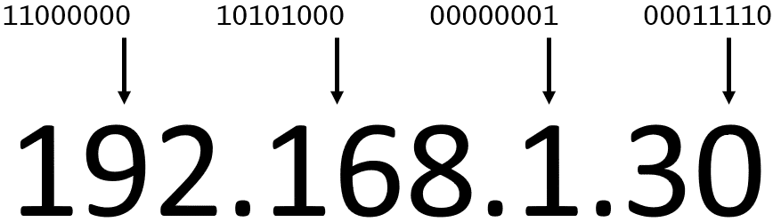
CIDR notation – CIDER lets you express on a range of IP addresses it lets you do that by putting a "/" before the flexible range, when you subtract the number after "/" from 32 you get the amount of flexible bits left in the address(in the example below its 32-24 = 8 flexible bits). That means that the higher the number after the "/" the smaller the amount of flexible bits.

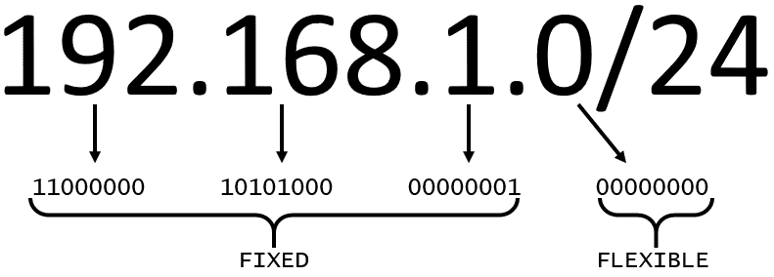
VPC (Virtual Private Cloud) – an isolated network that you can create in AWS, it mirrors a traditional network in a data center.
Subnets – there are two types of subnets in a VPC:
private which can only connect to the internet via NAT gateway is more secure.
public which can be connected to the net via a internet gateway.

Internet gateway – a way to connect the VPC and through it the public subnet on it to the net.
Virtual private gateway – a way to connect your VPC to a private network (office, home etc.). it does require a physical device or software(AWS Direct Connect for example ) on the customer side to let you use a VPN to connect to connect to the VPG and through it to the VPC.
AWS Direct Connect – a program by AWS that lets you connect your internal network such as home or office network to the VPC or AWS services
Main route table- when a VPC is created AWS creates a main route table with it to help route out the network traffic in and out of it. AWS on default allows traffic between all subnets in the local network. The main rout tables has rules such as: you cannot delete it OR replace it, you can add modify or delete routes in it, and you can change which subnets are associated with it.
Customs route tables – if you want to change the route of flow to a subnet you can create a custom route table, using it you are able to create different routes for the subnet and if a route is created for a subnet it will use it instead of the main one, keeping the VPC more protected and organized. 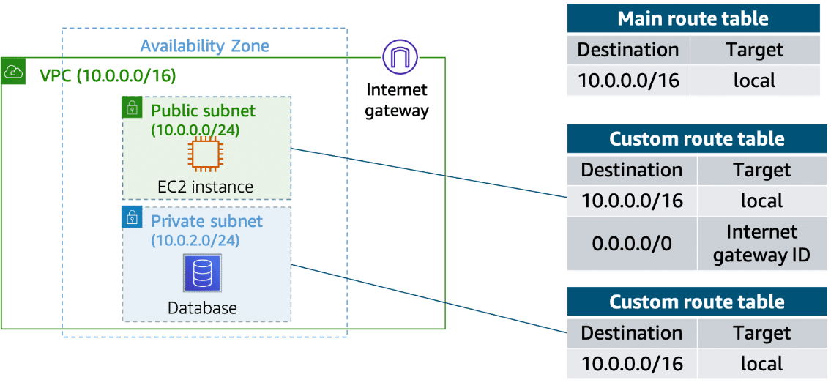
ACL – the ACL acts as a cyber firewall around the subnets controlling what is allowed in and out, the default settings allows free flow with no restrictions. Of course, you can create custom ones and modify them to your needs. An ACL is stateless which means that when you configure it its important to include inbound AND outbound gates that way the traffic has a way of leaving the subnets once it's done.
SECURITY GROUPS – just like ACL is for subnets security groups does the same for EC2, it acts as a firewall protecting and segregating an EC2. Because they are stateful unlike ACL you are allowed to create only an inbound port without creating an outbound one. Its good to mention that security groups block all inbound and outbound traffic on default.
AWS TECHNICAL ESSENTIALS PART 2
STORAGE
BLOCK STORAGE - Block storage is built in a way that splits the file up into smaller blocks thus any changes done to the file will be done on the smaller block and not the entire file. Because of that it is the perfect candidate for storing files that need to be changed a lot, since it will only change a small part of it. also good for storing containers because of their nature.
OBJECT STORAGE – object is different then block in the way it organizes the file. In object the file is stored in the same form it is given without being cut or changed, that makes it better for files that need to be read a lot but changed little since any changes are done on the full file(WORM = Write once Read many) . the difference between object and file storage is that in object the object itself is stored in a bucket using a flat structure, so unlike file where there is a path and directories in object its each one has a unique identifier that is bundled with the rest of the data and is stored together.
FILE STORAGE - file is our basic way of storing just like it is done on any normal computer, it works on folders and sub folders where each file has its own metadata like name size and more. It also has a path that the system knows to make retrieving it easier when needed. it is best used when you need a centralized storage system that Is easy to share info through and can be used by multiple host computers.
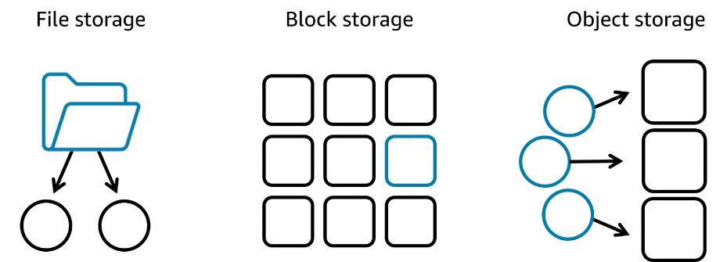
Amazon EFS – amazons app for file storage system, it can grow and shrink its storage size depending on its need, it has multiple storage classes like standard which works in multiple AZ zones, and one zone storage which works in only one AZ to make access easier.
Amazon FSX – FSX works much like EFS but has compatibility with windows, higher performance such as using lustre and is in general more compatible then EFS which is the main reason to use it.

EC2 instance store – on every EC2 instance there is a storage attached, it is built like that so you can connect to the data faster and to keep high performance since it's all stored locally on the EC2, that means that if the instance is deleted the data is deleted with it.

Amazon EBS – EBS is amazons' solution to that problem, it acts as an external hard drive connected to the EC2 and stores its data for It, it can be detached from it and connected to another EC2 so it can store its data or even give it the data that was stored on the EC2 Before it(all in the same AZ). It can even be attached to more then one EC2 instance needed.
EBS SCALING:
1. increase volume size - the simplest way is to just increase the size of the EBS, it goes up to 64 tebibytes.
2. attaching more then one EBS to a single EC2 - EC2 has a one to many relationships meaning it can have more then one EBS attached to it.
EBS VOLUME TYPES:
1. SSD – used for more small size workloads and transactional work, easier for read/write operations
2. HDD - HDDs are used for large streaming workloads that need high throughput performance.

EBS SNAPSHOTS – a simple way to back up your EBS data, it only saves the latest changed info, for example if your 10 gb file had 2gb changed that 2gb file will be saved into the snapshot ONLY. It is saved in a multiple AZ zone automatically by amazon.

S3 – S3 is an object storage service which lets the user retrieve the data from anywhere, it isn’t attached to an EC2 or VPC. Its completely accessible from the web. In S3 you store objects in Buckets, you cant upload anything to S3 without first creating a bucket. Buckets are per region so every name must be unique to not clash. S3 Has many different storage classes with different uses as well.
S3 OBJECT KEY – when creating an object in S3 you must give it a unique object key, you do that since S3 is an object storage type thus all its info is in a flat structure using the key to find it. 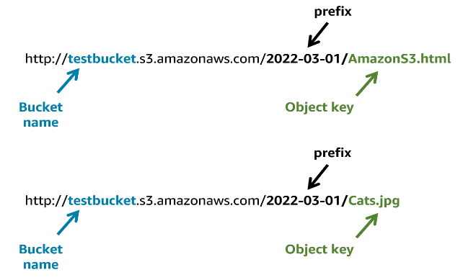

DATABASE
Database – used to store complex information in comparison to storage which is made for files
A simple rule of thumb:
If you can put it in a spreadsheet row → Database If you'd save it as a file on your computer → Storage
1.Relational databases - the most popular option, A relational database organizes data into tables. Data in one table can link to data in other tables to create relationships—hence, the relational part of the name. the relationship between the different parts of the table is called a logical schema, a schema becomes fixed once a database becomes operational that’s why the data modeling should be done before that. Example of relational database below:
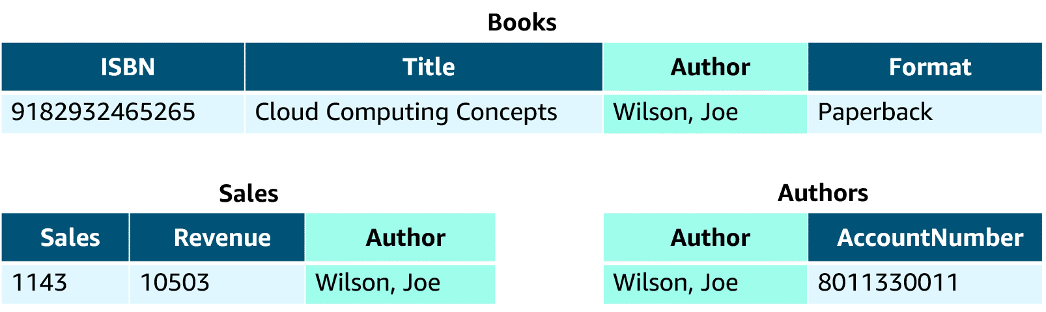
2.unmanaged database- in AWS we have two different options for how to manage a database, an unmanaged database lets AWS have control only on the hardware. While you have to take care of the scaling, patches, availability and more.
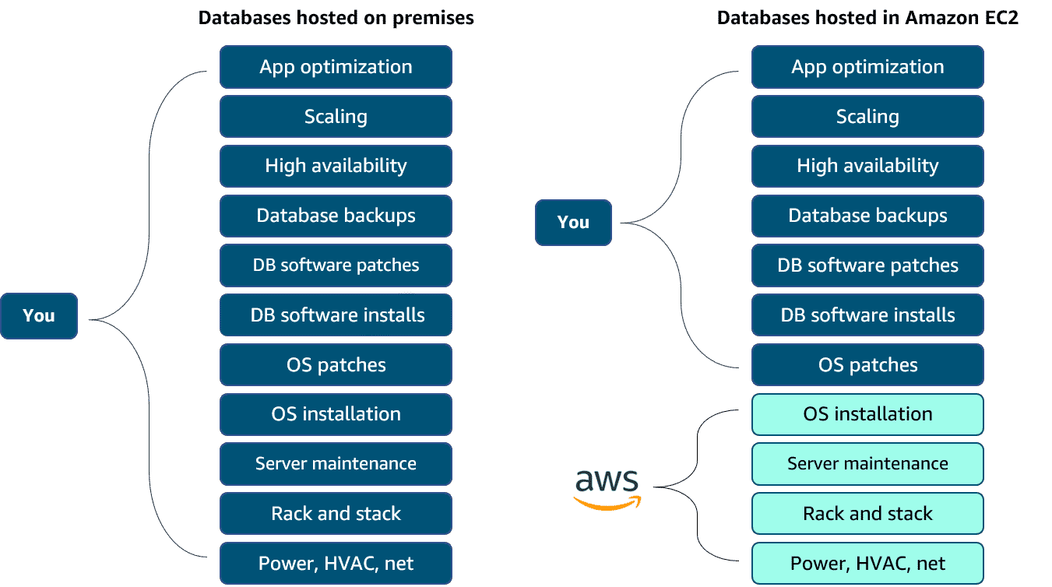
3.Managed database – on the other hand you can give most of the responsibility to AWS but that means less control over the database but gives you the setup of both the EC2 instance and the database, and they provide systems for high availability, scalability, patching, and backups. This option provides the ultimate convenience but the least amount of control compared to the two previous options.
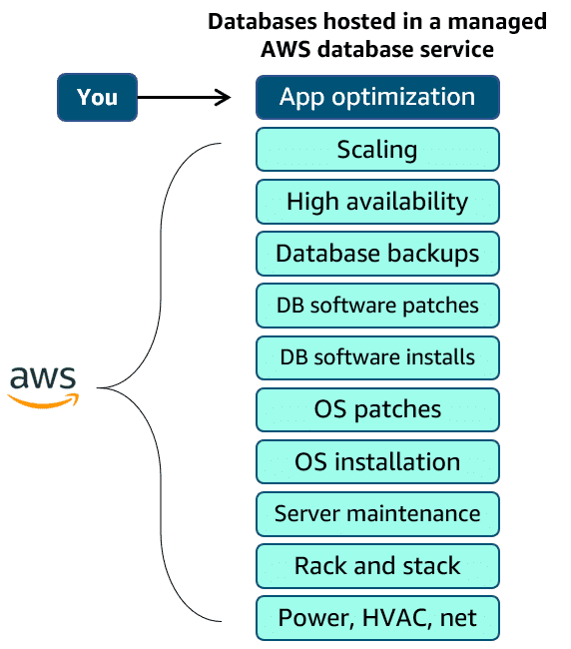
1. AMAZON RDS – amazons way of having a managed database service in AWS, it supports multiple RDBMS and is built like an EC2 with instances which you need to assign a size and type just like an EC2. You deploy a DB instance in a VPCA and then choose its dedicated subnet, also available is the ability to deploy in multiple AZ zones which creates a copy of your DB instance in a different AZ and syncs it to the primary one to make sure info is saved in case of a crash. It is also connected to the EC2 instance and in case of a problem with the primary DB the EC2 will switch to moving info to it.
2.DynamoDB – dynamo is the most popular option in AWS it is a fully managed NoSQL database it is great for two categories of applications: high scale and serverless. It can:
- Create database tables that can store and retrieve any amount of data and serve any level of request traffic.
- Scale up or scale down your tables' throughput capacity without
- Monitor resource usage and performance metrics using the AWS Management Console.
Dynamo also stores your data in multiple AZ zones and all its data is stored on SSD so its fast to pull. It also comes in with the ideal of creating IAM roles for security
3.ElastiCache - Use when speed is critical and you don't need to store data forever since the data is in the RAM so it isn’t permanent.
TIP: there are more databases available in AWS with different features for each application, it all depends on what your looking for.
Monitoring and scaling
CLOUDWATCH – AWSs main app for monitoring EC2s and applications, its main job is to collect data and create statistics for you to use all while monitoring your applications. You can use CloudWatch to create custom matrices and even alarms to alert you in case something goes wrong, alerts have three mods:
1.insufficient data - which means it doesn’t have enough metrics yet to decide and needs more time to collect.
2. ok – the metrics are inside the defined threshold.
3. in alert – which means the applications metrics are out of the defined threshold
You can also define an action for when an alarm is triggered, like sending an alert or email to someone to troubleshoot it. Another thing that can be done is program it so when an alarm is triggered it can automatically try to fix it if it’s a technical issue, like rebooting an EC2 instance or use a lambda function.
Load balancers - the point of having load balancers is to make sure our work load is been balanced correctly and to mitigate problems that happen when it doesn’t.
ELB – AWSs main load balancer, ELB is used to balance any kind of load(instance or otherwise) in an application. It is highly available and scalable, as well as a health checker on your instances.
When you create an ELB you must set a listener, whose job is to for traffic and then route it to a healthy and none busy instance. And you must create a target group, it is the place where you direct your traffic to. You must also create a rule, a rule helps associate a target group with a listener, it is made of two conditions, the first is the source of the IP and the second decides to which target group to send the traffic. There are 3 types of ELB in AWS:
1. Application Load Balancer - functions on layer 7 and best for balancing HTTP and HTTPS traffic, After the load balancer receives a request, it evaluates the listener rules in priority order to determine which rule to apply. It then routes traffic to targets based on the request content.
2. Network Load Balancer - A Network Load Balancer is ideal for load balancing TCP and UDP traffic. It functions at Layer 4 of the OSI model, routing connections from a target in the target group based on IP protocol data.
3. Gateway Load Balancer - A Gateway Load Balancer helps you to deploy, scale, and manage your third-party appliances, such as firewalls, intrusion detection and prevention systems, and deep packet inspection systems. It provides a gateway for distributing traffic across multiple virtual appliances while scaling them up and down based on demand.
EC2 AUTO SCALING – AWS allows us to create an auto scaling target group by creating a launch template in which you set the parameters for how the EC2 will work, the auto scaler creates new EC2 instances whenever the ELB and CLOUDWATCH say the applications is too stressed, the amount of EC2s and when to create then is available to change when you create the target group, they will also scale down once CLOUDWATCH shows it isn’t needed, all without human infractions.
